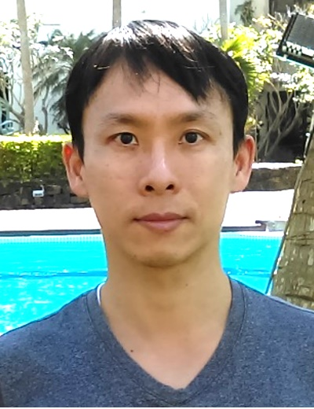

**Biography**

Dr. Kun-Yu Lai is currently a professor in the Department of Optics and Photonics (DOP) at National Central University (NCU) in Taiwan. Prof. Lai received his Ph.D. degree in Electrical Engineering from North Carolina State University in USA in 2009. After working as the postdoctoral fellow in the Graduate Institute of Photonics and Optoelectronics at National Taiwan University in 2009-2011, he joined the faculty in DOP at NCU. Prof. Lai specializes in the growth/fabrication of novel III-nitride optoelectronic devices, including plasmonic biosensors and LEDs. He has published 56 articles in peer-reviewed SCI journals, with a total citation over 1700 times (H-index: 24). Detailed information on Prof. Lai’s research is available at: <http://kylai.cloudweb.com.tw/>